**SMART FARMER – IoT ENABLED SMART FARMER APPLICATION**

**ASSIGNMENT - 3**

|  |  |
| --- | --- |
| **NAME** | **ROLL NO** |
| Adarsh Karan K P | 718019L101 |

**Write a python code for blinking LED and Traffic Lights for Raspberry Pi.**

**(i) Python Code for Blinking LED:**

#import RPi.GPIO as GPIO

#from gpiozero import LED

from time import sleep

#led = LED(17)

while True:

#led.on()

print("LED turned ON")

sleep(1)

#led.off()

print("LED turned OFF")

sleep(1)

**Editor Window:**

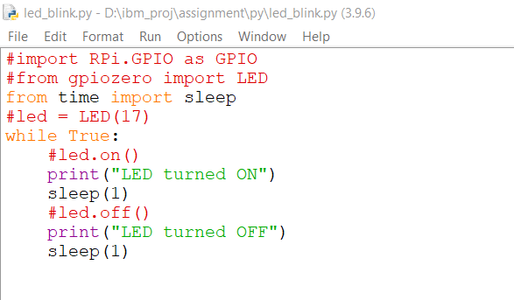

**Output Window:**

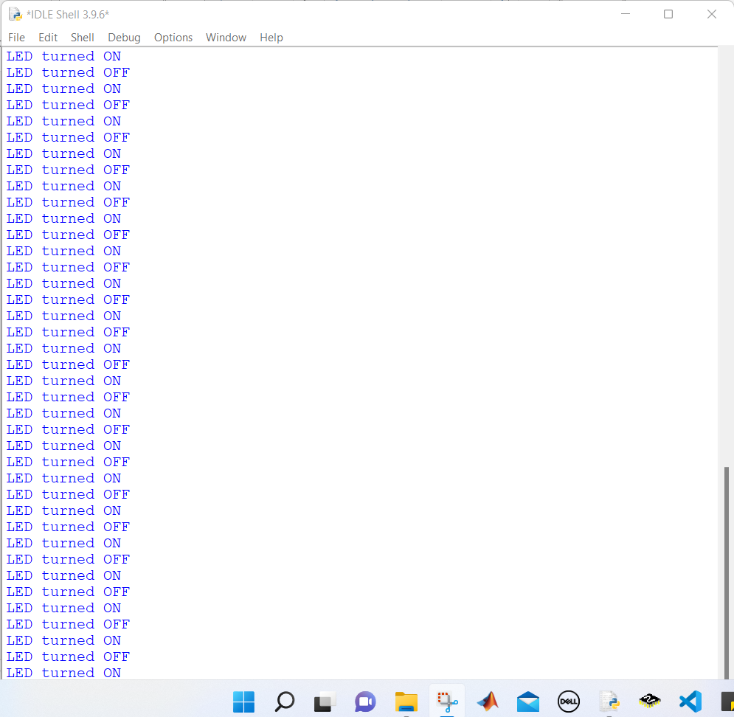

**(ii) Python Code for Traffic Lights:**

import RPi.GPIO as GPIO

import time

import signal

import sys

#setup

GPIO.setmode(GPIO.BCM)

GPIO.setup(9, GPIO.OUT)

GPIO.setup(10, GPIO.OUT)

GPIO.setup(11, GPIO.OUT)

#Turn off all lights

def allLightOff(signal, frame):

GPIO.output(9,False)

GPIO.output(10,False)

GPIO.output(11,False)

GPIO.cleanup()

sys.exit(0)

signal.signal(signal.SIGINT, allLightsOff)

#Forever Loop

while True:

#Red

GPIO.output(9, True)

time.sleep(3)

GPIO.output(10, True)

time.sleep(1)

#Green

GPIO.output(9,False)

GPIO.output(10,False)

GPIO.output(11,True)

time.sleep(5)

#Amber

GPIO.output(11,False)

GPIO.output(10,True)

time.sleep(2)

#Amber off

GPIO.output(10,False)

**Editor Window:**

